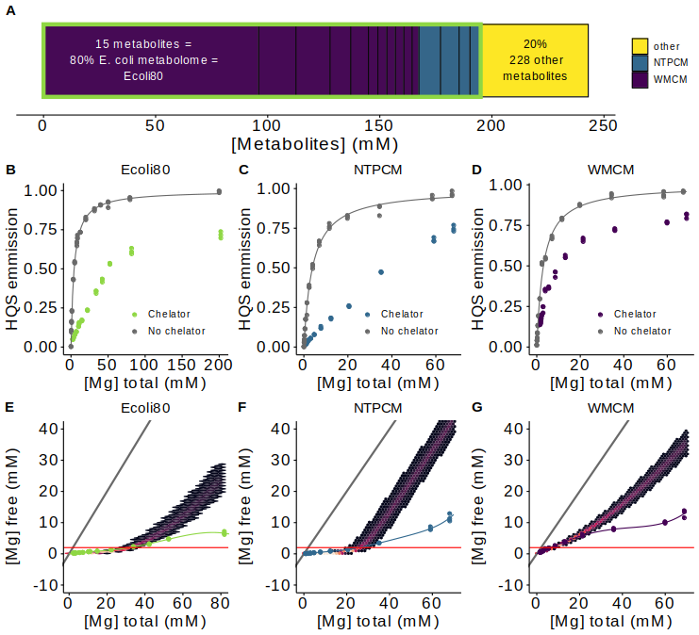

**Figure 1** *E. coli* metabolite and Mg2+ mixtures approximate single site binding near 2 mM free Mg2+. **(A)** E. coli metabolome molar composition. **(B-D)** Effect of Mg2+ on 8-hydroxyquinoline-5-sulphonic acid (HQS) emission with and without mixtures of metabolites that chelate Mg2+. Grey lines represent fits to determine the binding constant for Mg2+ and HQS. **(E-G)** Effect of the total Mg2+ concentration on the free Mg2+ concentration with mixtures of metabolites that chelate Mg2+. Free Mg2+ was calculated using HQS emission and the binding constant for Mg2+ and HQS. Grey lines represent the free Mg2+ concentration in the absence of chelators (free Mg2+ = total Mg2+). Hex bins represent a statistical simulation based on experimental errors in KD determination, experimental errors in reagent concentrations, and single site binding.

**Table 1.** Eco80: the top 15 most abundant metabolites that comprise 80% of the E. coli metabolome.

|  |  |  |  |
| --- | --- | --- | --- |
| Metabolite | Conc. (mM) | K’D  (mM) | Chelation stength |
| ATP | 9.63 | 0.28 (0.01)a | Strongd |
| UTP | 8.29 | 0.248 (0.004)a | Strongd |
| GTP | 4.87 | 0.201 (0.007)a | Strongd |
| dTTP | 4.62 | 0.160 (0.003)a | Strongd |
| L-Glutamic acid | 96 | 520 (50)b | Weakd |
| Glutathione | 16.6 | NAc | Weakd |
| Fructose 1,6-BP | 15.2 | 5.9 (0.1)a | Weakd |
| UDP-GlcNAC | 9.24 | 29 (2)a | Weakd |
| Glucose 6-P | 7.88 | 17.3 (0.2)a | Weakd |
| L-Aspartic acid | 4.23 | 465 (12)b | Weakd |
| L-Valine | 4.02 | NAc | Weakd |
| L-Glutamine | 3.81 | NAc | Weakd |
| 6-P-gluconic acid | 3.77 | 14.4 (0.2)a | Weakd |
| Pyruvic acid | 3.66 | 435 (16)b | Weakd |
| Dihydroxyacetone phosphate | 3.06 | 20 (1)a | Weakd |

aDetermined at 37 °C with Isothermal titration calorimetry. Error is the propagated standard error in the fit parameters.

bDetermined at 37 °C with HQS emission Error is the propagated standard error in the fit parameters.

cNo binding observed as per SI Figure 2

dMetabolites with KDs for Mg2+ less than 2 mM are considered strong Mg2+ chelators.

**SI Table 1.** Recipe for the Eco80 artificial cytoplasm (Add in later in word when I am formatting the tables)

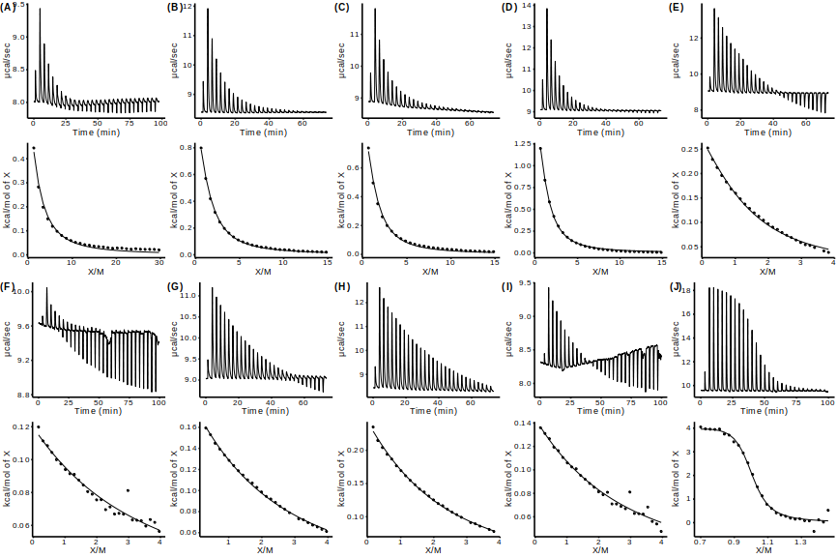SI Figure 1 Isothermal titration calorimetry (ITC) analysis of Mg2+ binding to metabolites.

SI Table 2 Apparent binding constants determined with Isothermal titration calorimetry (ITC).

|  |  |  |  |  |  |
| --- | --- | --- | --- | --- | --- |
| Metabolite | Syringe (mM) | Cell (mM) | dH (kcal/mol) | K’ (M-1) | KD’ (mM-1) |
| ATP | 15 mM MgCl2a | 0.1 mM ATPa | 1.83 (0.04) | 3600 (200) | 0.28 (0.01) |
| UTP | 15 mM MgCl2a | 0.2 mM UTPa | 1.70 (0.01) | 4200 (70) | 0.248 (0.004) |
| GTP | 15 mM MgCl2a | 0.2 mM GTPa | 1.43 (0.02) | 5000 (200) | 0.201 (0.007) |
| dTTP | 15 mM MgCl2a | 0.2 mM dTTPa | 2.19 (0.02) | 6300 (300) | 0.160 (0.003) |
| Fructose 1,6-BP | 100 mM MgCl2a | 5.0 mM Fructose 1,6-BPa | 0.414 (0.004) | 169 (4) | 5.9 (0.1) |
| UDP-GlcNAC | 100 mM MgCl2a | 5.0 mM UDP-GlcNAC | 0.57 (0.02) | 34 (2) | 29 (2) |
| Glucose 6-P | 100 mM MgCl2a | 5.0 mM Glucose 6-Pa | 0.555 (0.003) | 57.9 (0.7) | 17.3 (0.2) |
| 6-P-gluconic acid | 100 mM MgCl2a | 5.0 mM 6-P-gluconic acida | 0.662 (0.005) | 70 (1) | 14.4 (0.2) |
| Dihydroxyacetone phosphate | 100 mM MgCl2a | 5.0 mM dihydroxy-acetone phosphatea | 0.50 (0.01) | 51 (3) | 20 (1) |
| EDTA | 6 mM MgCl2a | 1.5 mM EDTA 1.0 mM MgCl2a | 2.85 (0.04) | 220,000 (30,000) | 0.0045 (0.0006) |

a240 mM NaCl 140 mM KCl 10 mM HEPES pH 7.0 at 37 °C

bMg2+ and EDTA were incorporated into the cell in order to sequester trace tight binding metal ions and thereby negate their contribution to ITC signal.

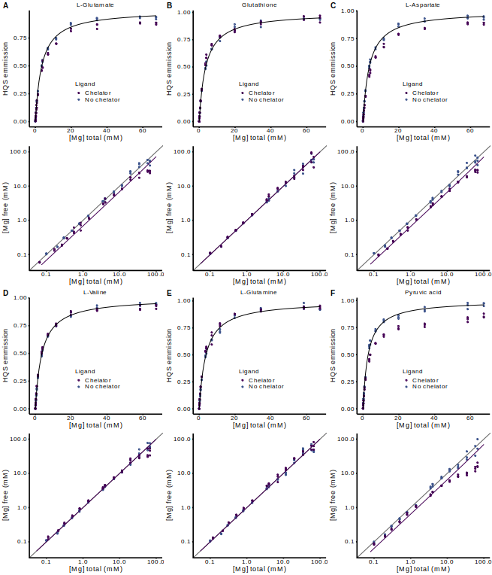**SI Figure 2** HQS analysis of Mg2+ binding to metabolites.

SI Table 3 Apparent binding constants determined with HQS emission.

|  |  |  |  |  |  |
| --- | --- | --- | --- | --- | --- |
| Metabolite | Fmax | Fmin | KHQS (mM-1) | K’ (mM-1) | KD’ (mM-1) |
| L-Glutamic acid | 187,000 (1000) | 0 (810) | 0.281 (0.008) | 0.0019 (0.0002) | 520 (50) |
| Glutathione | 182,000 (1000) | 592 (750) | 0.279 (0.007) | NAc | NAc |
| L-Aspartic acid | 196,000 (1000) | 0 (820) | 0.283 (0.007) | 0.0021 (0.0001) | 465 (12) |
| L-Valine | 188,200 (800) | 495 (580) | 0.274 (0.005) | NAc | NAc |
| L-Glutamine | 190,000 (1400) | 516 (110) | 0.27 (0.01) | NAc | NAc |
| Pyruvic acid | 188,000 (1500) | 0 (1300) | 0.35 (0.01) | 0.0023 (0.0001) | 435 (16) |

cNo binding observed as per SI Figure 2

Table 2. Total Mg2+ concentrations used to obtain 2mM free Mg2+ in artificial cytoplasms.

|  |  |  |  |  |
| --- | --- | --- | --- | --- |
| Condition | Observation | Total [Mg2+] (mM) | Chelated [Mg2+] (mM) | Free [Mg2+] (mM) |
| Eco80 | min | 22.0 | 20.7 | 1.3 |
| Used | 31.6 | 29.6 | 2.0 |
| max | 34.0 | 31.7 | 2.3 |
| NTPCM | min | 19.9 | 18.6 | 1.3 |
| Used | 25.0 | 23 | 2.0 |
| max | 34.5 | 31 | 3.5 |
| WMCM | min | 5.5 | 3.8 | 1.7 |
| Used | 6.5 | 4.5 | 2.0 |
| max | 8.5 | 6 | 2.5 |

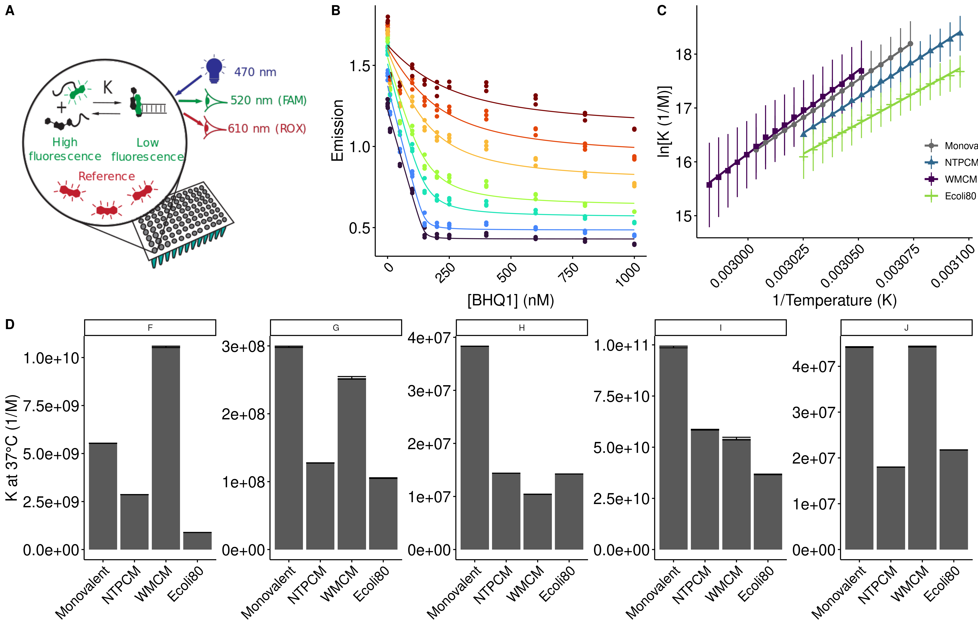**Figure 2** *E. coli* metabolite and Mg2+ mixtures destabilize RNA secondary structure.

Table 3. Stability of RNA helices in *E. coli* **metabolite mixtures.**

|  |  |  |  |  |  |  |  |
| --- | --- | --- | --- | --- | --- | --- | --- |
| Helix | Sequence (5'-FAM/ BHQ1-3') | AU  content | Condition | dH (kcal/mol) | dS (cal/mol/K) | dG (kcal/mol) | ddG (kcal/mol) |
| F | CGCAUCCU/AGGAUGCG | 0.38 | 2 mM free | -55.9 (0.2) | -136.0 (0.7) | -13.82 (0.01) |  |
| NTPCM | -52.2 (0.4) | -125 (1) | -13.41 (0.02) | 0.41 (0.02) |
| WMCM | -61.4 (0.8) | -152 (2) | -14.22 (0.05) | -0.40 (0.05) |
| Ecoli80 | -44.5 (0.7) | -102 (2) | -12.70 (0.04) | 1.13 (0.04) |
| G | CCAUAUCA/UGAUAUGG | 0.63 | 2 mM free | -53.4 (1.0) | -133 (3) | -12.02 (0.04) |  |
| NTPCM | -42.9 (0.5) | -101 (1) | -11.50 (0.02) | 0.52 (0.04) |
| WMCM | -53 (2) | -132 (7) | -11.9 (0.1) | 0.10 (0.01) |
| Ecoli80 | -57 (2) | -146 (5) | -11.38 (0.05) | 0.64 (0.06) |
| H | CCAUAUUA/UAAUAUGG | 0.75 | 2 mM free | -53.5 (0.4) | -137 (1) | -10.76 (0.01) |  |
| NTPCM | -45.0 (0.2) | -112.5 (0.5) | -10.158 (0.002) | 0.60 (0.01) |
| WMCM | -43 (2) | -107 (5) | -9.94 (0.02) | 0.80 (0.02) |
| Ecoli80 | -41.3 (0.2) | -100.4 (0.7) | -10.15 (0.01) | 0.61 (0.01) |
| I | CGGAUGGC/GCCAUCCG | 0.25 | 2 mM free | -71.1 (0.8) | -179 (2) | -15.6 (0.06) |  |
| NTPCM | -70.4 (0.6) | -177 (2) | -15.28 (0.05) | 0.32 (0.08) |
| WMCM | -65.5 (2) | -162 (7) | -15.2 (0.2) | 0.4 (0.2) |
| Ecoli80 | -69.7 (0.8) | -176 (3) | -14.0 (0.1) | 0.61 (0.08) |
| J | CGUAUGUA/UACAUACG | 0.63 | 2 mM free | -63.2 (0.9) | -169 (3) | -10.85 (0.02) |  |
| NTPCM | -59 (1) | -157 (4) | -10.30 (0.01) | 0.55 (0.02) |
| WMCM | -67 (1) | -180 (3) | -10.85 (0.02) | 0.00 (0.03) |
| Ecoli80 | -61 (1) | -164 (3) | -10.41 (0.01) | 0.44 (0.02) |

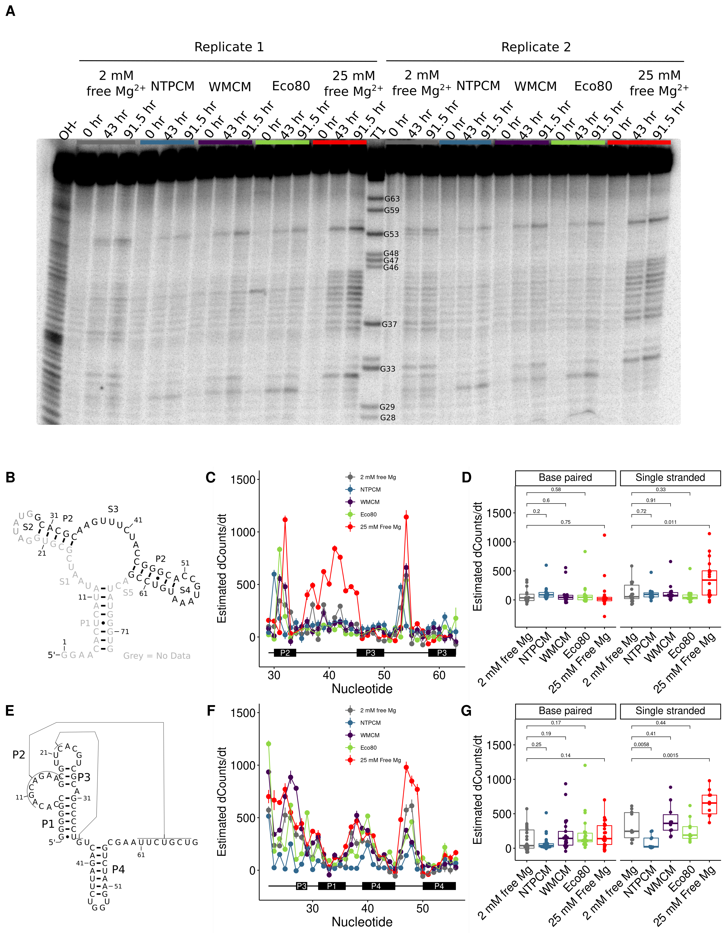

**Figure 3** *E. coli* metabolite and Mg2+ mixtures stabilize the chemical structure of RNA. **(A)** Raw degradation assay gel image for the Guanine riboswitch aptamer incubated in artificial cytoplasms at 37 °C and pH 7. The OH- lane contains a hydrolysis ladder which cleaves after every nucleotide and T1 contains the RNA treated with T1 ribonuclease which cleaves after every G. Enough Mg2+ was added to each artificial cytoplasm to have 2 mM Mg2+  as determined in Figure 1. **(B)** Secondary structure of the guanine riboswitch aptamer. **(C)** Estimated increase in counts as a function of time at each residue in different solution conditions as a function of location in the RNA. **(D)** Estimated increase in counts as a function of time in different conditions grouped by paired and unpaired bases. Significance was determined using a student’s t-test. **(E)** Secondary structure of the cleaved human CPEB3 HDV ribozyme. **(C)** Estimated increase in counts as a function of time at each residue in different solution conditions as a function of location in the RNA. **(D)** Estimated increase in counts as a function of time in different conditions grouped by paired and unpaired bases. Significance was determined using a student’s t-test.

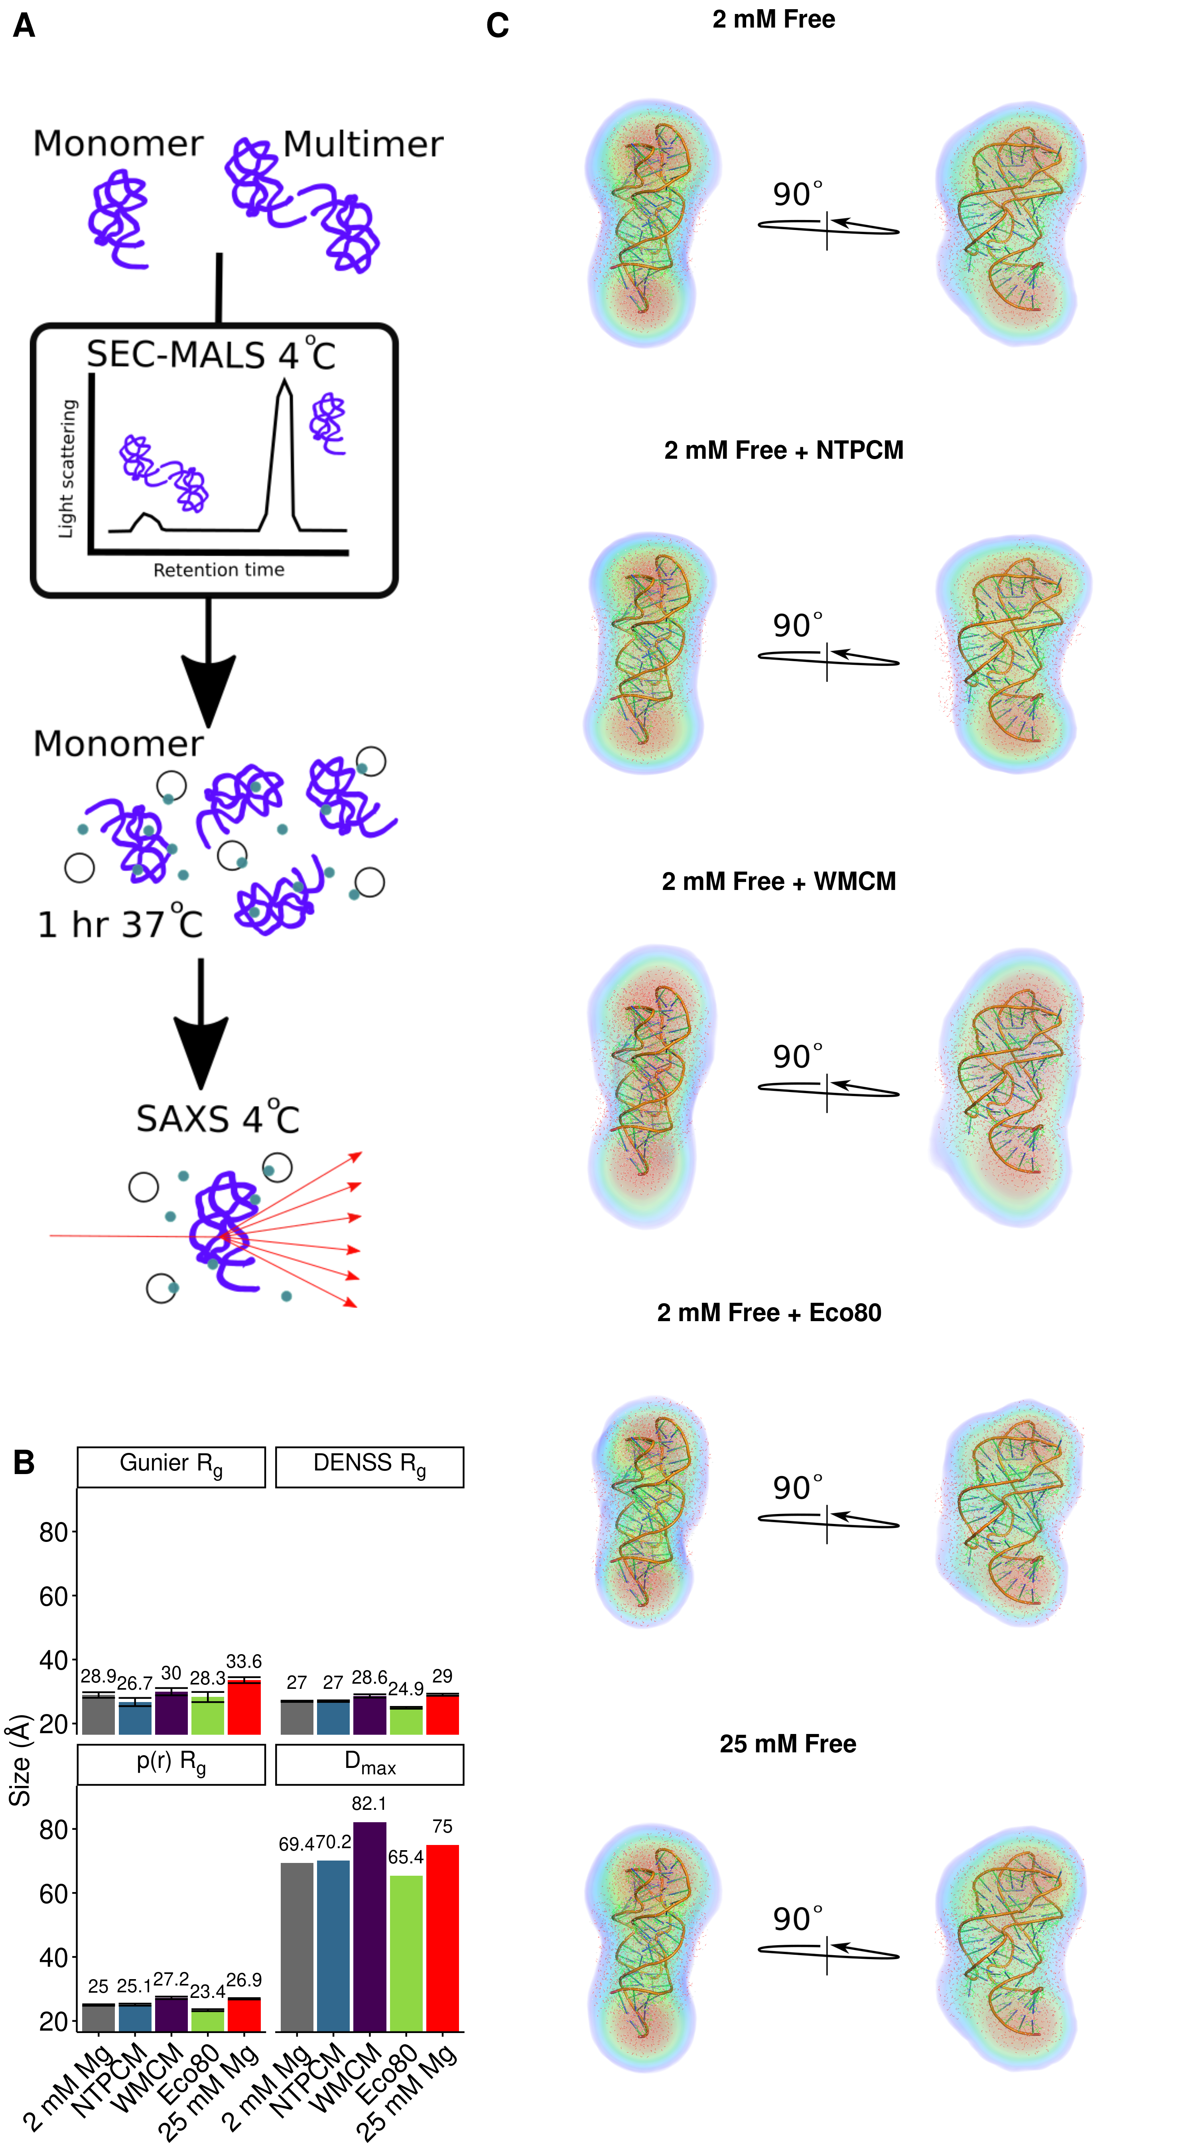

**Figure 4** *E. coli* metabolite and Mg2+ mixtures increase functional RNA compactness.